PRIYANKA D

240801256

ECE D

# Question text 1

You are given a two-dimensional 3*3 array starting from A [0][0].

You should add the alternate elements of the array

and print its sum. It should print two different numbers the first being sum of A 0 0, A 0 2, A 1 1, A 2 0, A 2 2 and A 0 1,

A 1 0, A 1 2, A 2 1.

# Input Format

First and only line contains the value of array separated by single space.

# Output Format

First line should print sum of A 0 0, A 0 2, A 1 1, A 2 0, A 2 2

Second line should print sum of A 0 1, A 1 0, A 1 2, A 2 1

# SAMPLE INPUT

1 2 3 4 5 6 7 8 9

# SAMPLE OUTPUT

25

20

# Question text 2

Microsoft has come to hire interns from your college. N students got shortlisted out of which few were males and a few

females. All the students have been assigned talent levels. Smaller the talent level, lesser is your chance to be selected.

Microsoft wants to create the result list where it wants the candidates sorted according to their talent levels, but there

is a catch. This time Microsoft wants to hire female candidates first and then male candidates.

The task is to create a list where first all-female candidates are sorted in a descending order and then male candidates

are sorted in a descending order. Input Format

The first line contains an integer N denoting the number of students.

Next, N lines contain two space-separated integers, ai and bi.

The first integer, ai will be either 1(for a male candidate) or 0(for female candidate).

The second integer, bi will be the candidate's talent level. Constraints

***1 <= N <= 10 5***

***0 <= ai <= 1***

***1 <= bi <= 10 9***

Output Format

Output space-separated integers, which first contains the talent levels of all female candidates sorted in descending

order and then the talent levels of male candidates in descending order.

SAMPLE INPUT 5

0 3

1 6

0 2

0 7

1 15

SAMPLE OUTPUT 7 3 2 15 6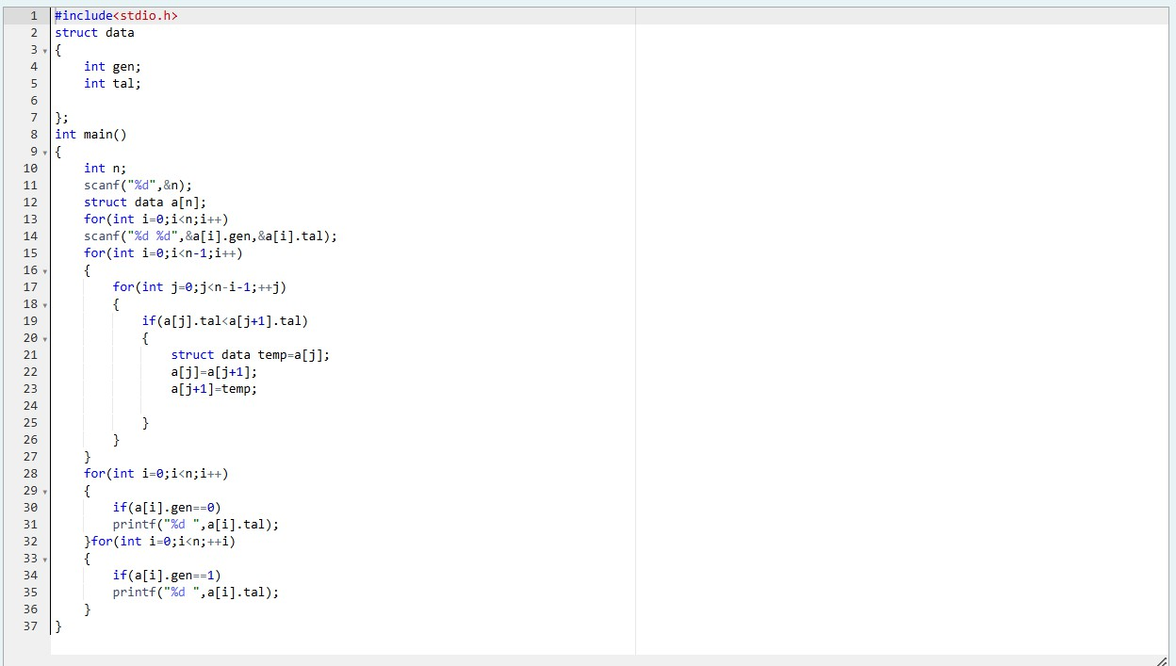

# Question text 3

Shyam Lal, a wealthy landlord from the state of Rajasthan, being an old fellow and tired of doing hard work, decided to

sell all his farmland and to live rest of his life with that money. No other farmer is rich enough to buy all his land so he

decided to partition the land into rectangular plots of different sizes with different cost per unit area. So, he sold these

plots to the farmers but made a mistake. Being illiterate, he made partitions that could be overlapping. When the

farmers came to know about it, they ran to him for compensation of extra money they paid to him. So, he decided to

return all the money to the farmers of that land which was overlapping with other farmer's land to settle down the

conflict. All the portion of conflicted land will be taken back by the landlord.

To decide the total compensation, he has to calculate the total amount of money to return back to farmers with the

same cost they had purchased from him. Suppose, Shyam Lal has a total land area of ***1000 x 1000*** equal square blocks

where each block is equivalent to a unit square area which can be represented on the co-ordinate axis. Now find the

total amount of money, he has to return to the farmers. Help Shyam Lal to accomplish this task.

# Input Format:

The first line of the input contains an integer ***N***, denoting the total number of land pieces he had distributed. Next ***N***

line contains the ***5*** space separated integers ***(X1, Y1)***, ***(X2, Y2)*** to represent a rectangular piece of land, and cost per

unit area ***C***.

***(X1, Y1)*** and ***(X2, Y2)*** are the locations of first and last square block on the diagonal of the rectangular region.

Output Format:

Print the total amount he has to return to farmers to solve the conflict. Constraints:

***1 ≤ N ≤ 100***

***1 ≤ X1 ≤ X2 ≤ 1000***

***1 ≤ Y1 ≤ Y2 ≤ 1000***

***1 ≤ C ≤ 1000*** SAMPLE INPUT 3

1 4 4 6 1

4 3 6 6 2

2 2 5 4 3

SAMPLE OUTPUT 35

Explanation 87vk

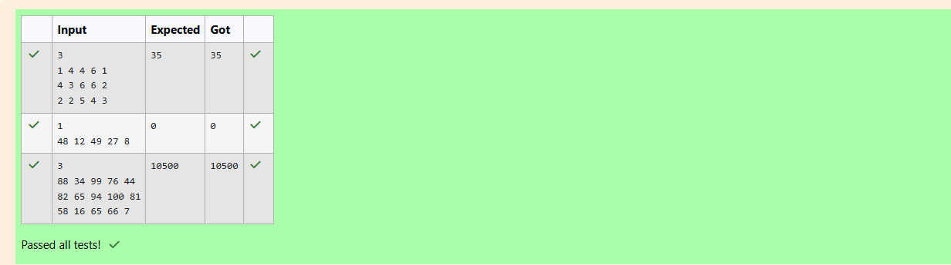For given sample input (see given graph for reference), compensation money for different farmers is as follows:

Farmer with land area A: C1 = 5 * 1 = 5 Farmer with land area B: C2 = 6 * 2 = 12 Farmer with land area C: C3 = 6 * 3 = 18

Total Compensation Money = C1 + C2 + C3 = 5 + 12 + 18 = 35